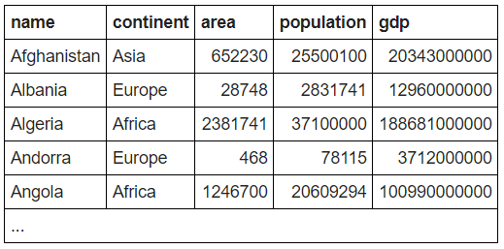

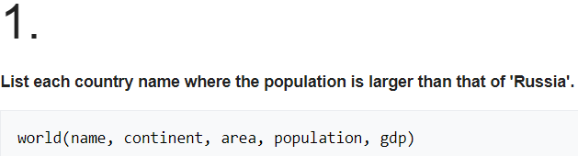

**SELECT name FROM world WHERE population > (SELECT population FROM world WHERE name='Russia')**



**SELECT name FROM world WHERE gdp/population > (SELECT gdp/population FROM world WHERE name = 'United Kingdom') AND continent = 'Europe'**

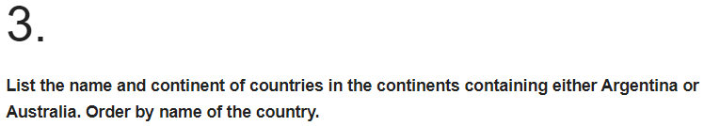

**SELECT name, continent FROM world WHERE continent IN (SELECT continent FROM world WHERE name IN ('Argentina', 'Australia')) ORDER BY name**

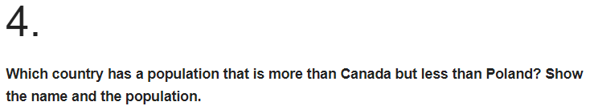

**SELECT name FROM world WHERE population > (SELECT population FROM world WHERE name = 'Canada') AND population < (SELECT population FROM world WHERE name = 'Poland')**

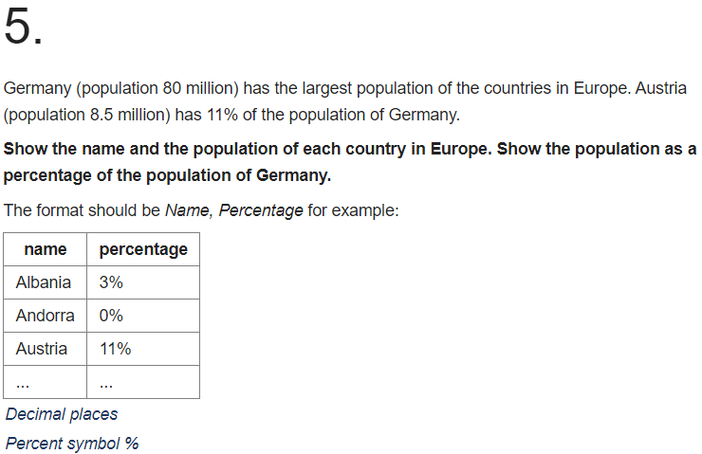

**SELECT**

**name,**

**CONCAT(ROUND((population*100)/(SELECT population**

**FROM world WHERE name='Germany'), 0), '%')**

**FROM world**

**WHERE population IN (SELECT population**

**FROM world**

**WHERE continent='Europe')**

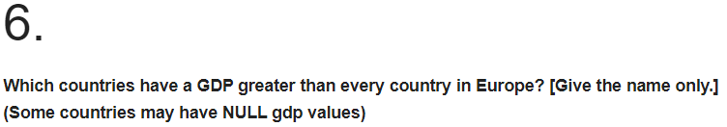

**SELECT name FROM world WHERE GDP > ALL(SELECT GDP FROM world where GDP > 0 and continent= 'Europe')**

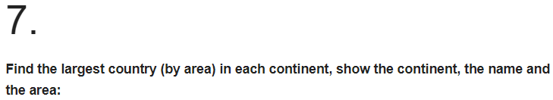

**SELECT continent, name, area FROM world x WHERE area >= ALL (SELECT area FROM world y**

**WHERE y.continent=x.continent AND area>0)**



**SELECT continent, name FROM world x WHERE name <= ALL(SELECT name FROM world y WHERE y.continent = x.continent)**

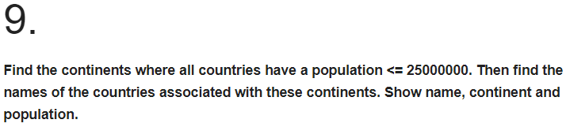

**SELECT name, continent, population FROM world x WHERE 25000000 > ALL(SELECT population FROM world y WHERE x.continent = y.continent AND y.population > 0)**

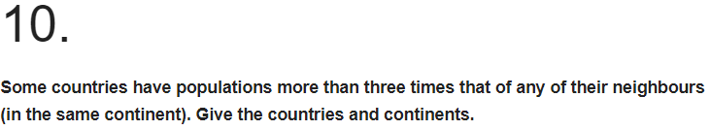

**SELECT name, continent FROM world x WHERE population > ALL(SELECT population*3 FROM world y WHERE x.continent = y.continent AND population > 0 AND y.name != x.name)**